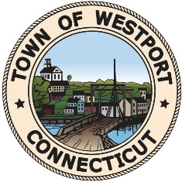
WESTPORT, CONNECTICUT
OFFICE OF THE CONTROLLER
TOWN HALL, 110 MYRTLE AVE.
WESTPORT, CONNECTICUT 06880
(203) 341-1080

TOWN OF WESTPORT, CONNECTICUT

NOTICE TO BIDDERS

BID NUMBER: _20-997T

Sealed bids for:
Coleytown Middle School
255 North Avenue
Westport, Connecticut

IT Work

will be received by the Town of Westport until

2:00 PM FRIDAY MAY 1, 2020
At
Westport Town Hall
110 Myrtle Avenue
Westport, CT 06880

DO TO THE CURRENT CLOSURE OF TOWN HALL TO THE PUBLIC ALL BIDS MUST BE SENT VIA MAIL OR UPS OR FED-EX.
Please mark the outside packaging of your bid with the BID # 20-997T
Bids will be opened on Monday May 4, 2020.
We will work out a method for the bid opening either via Zoom conferencing or via telephone conferencing. Bid results will also be sent out via email to each respondent.

No bids will be received after said hour. Copies of the bid documents may be obtained by downloading the information from the Town’s website:

www.westportct.gov/bids

The Town of Westport reserves the right to waive any defects and informalities in the bidding or in any bid, to reject any or all bids for any reason whatsoever, and to accept that bid deemed to be in the best interest of the Town of Westport.

Gary Conrad
Finance Director

