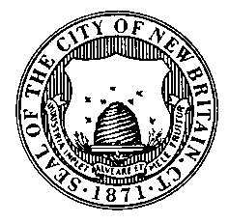
CITY OF NEW BRITAIN
Finance department
www.newbritainct.gov
EST. 1871

CITY OF NEW BRITAIN

NOTICE INVITING BIDS

Date: February 14, 2020

Bid No.: 4014

Bid Name: Mobil Food and Ice Cream Truck Concessions Rights for Various City
Parks

Summary: Sale of Mobil Food and Ice Cream Truck Concession Rights for Chesley Park, Martha Hart Park, A.W. Stanley Park, Stanley Quarter Park, Osgood Park, Willow Street Park Walnut Hill Park and Washington Park for the Period of April 01, 2020 through March 31, 2021.

Pre-Bid: None
Bonding: None

Date and Time of Bid Opening: March 13, 2020 at 11:00 a.m.

Specifications are Available On-Line:
http://www.das.state.ct.us/Purchase/Portal/Portal_Bids_Open.asp?F_Bid_Type=1&F_Unit=New%20Britain
or
http://newbritainct.gov/bids

Please note that it is the vendors’ responsibility to check on-line prior to bid opening to determine if addenda have been issued.

Jack Pieper

Purchasing Agent

