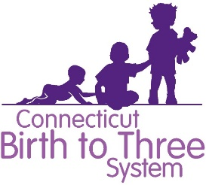

Permission to View Video Images

For Caregivers and program staff:

I , grant permission to the State of Connecticut
(print name)

Office of Early Childhood, lead agency for the Birth to Three System, the right to view the video clip that I appear

in as part of the proposal being submitted by
(agency or program name)

to operate a Comprehensive Early Intervention Service (EIS) Program.

I understand that the video will only be used for the purpose stated above, and will not be edited, modified or shown for any other purpose.

(Signature) (Date)

For parents or legal guardians:

I addition as the of the child who appears in this video I approve of
(relationship to child)

their participation in this video and grant permission for the viewing of this video clip.

(Signature) (Date)

