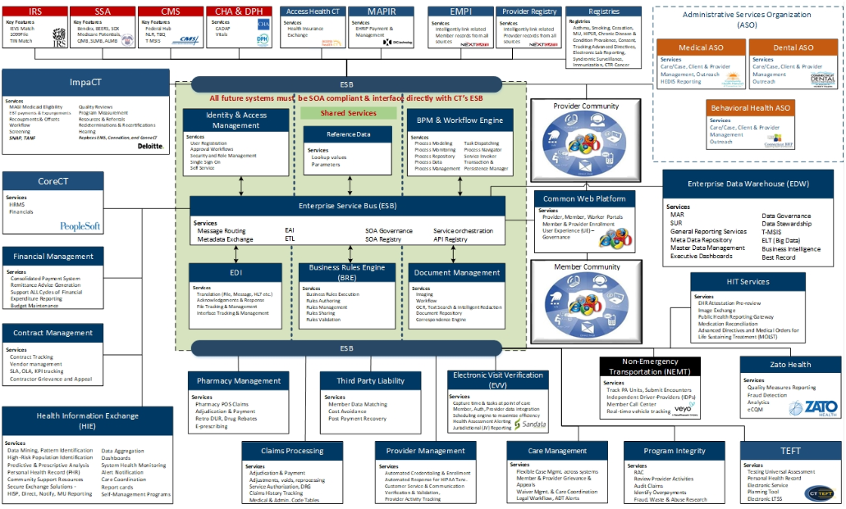
Note: Currently, the expectation is that MAPIR and EHR Attestation will sunset prior to the expected full implementation date.

