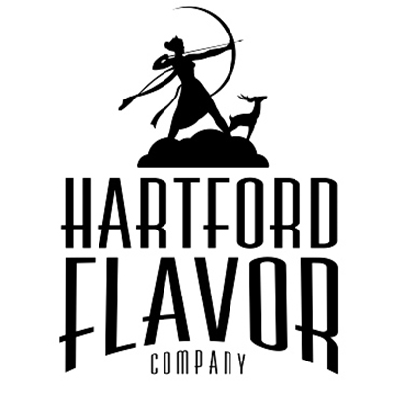
Hartford Flavor Company
30 Arbor St., Suite 107
Hartford, CT 06106
www.HartfordFlavor.com
Lelaneia@HartfordFlavor.com
860.604.9767
DSP-CT-21008
CT Lic # LML522

Wild Moon Liqueurs CT FOB Price List February, 2021
FLAVOR Size 375 Bottle Case of 12
Wild Moon Cucumber 375 ml $12.00 $144.00
Wild Moon Rose 375 ml $12.00 $144.00

Wild Moon Lavender 375 ml $12.00 $144.00
Wild Moon Birch 375 ml $12.00 $144.00
Wild Moon Chai Spice 375 ml $12.00 $144.00
Wild Moon Cranberry 375 ml $12.00 $144.00
Wild Moon Lime 375 ml $12.00 $144.00
FLAVOR Size 750 Bottle Case of 12
Wild Moon Cucumber 750 ml $19.00 $228.00
Wild Moon Rose 750 ml $19.00 $228.00
Wild Moon Lavender 750 ml $19.00 $228.00
Wild Moon Birch 750 ml $19.00 $228.00
Wild Moon Chai Spice 750 ml $19.00 $228.00
Wild Moon Cranberry 750 ml $19.00 $228.00
Wild Moon Lime 750 ml $19.00 $228.00

FLAVOR Size 100 Bottle_____Case of 24
Wild Moon Cucumber 100 ml $2.71 $65.04
Wild Moon Rose 100ml $2.71 $65.04
Wild Moon Lavender 100 ml $2.71 $65.04
Wild Moon Birch 100 ml $2.71 $65.04
Wild Moon Chai Spice 100 ml $2.71 $65.04
Wild Moon Cranberry 100 ml $2.71 $65.04
Wild Moon Lime 100 ml $2.71 $65.04
Variety Pack Size 6 pack Case of 4
6 pack, one of each flavor, 100 ml size ea. $18.30 case of 4 = $73.20
--------------------------------------------------------------------------------------------------------------------------------------------------
Wild Moon Botanics _______Size 375ml Bottle______Case of 12
Wild Moon Botanics 7 Lemon 375ml $14.00 $168.00
Wild Moon Botanics Roasted Dandelion Root 375ml $14.00 $168.00
Wild Moon Botanics Sage 375ml $14.00 $168.00
Wild Moon Botanics Sumac 375ml $14.00 $168.00

Wild Moon Botanics _______Size 750ml Case of 12
Wild Moon Botanics 7 Lemon 750ml $21.00 $252.00
Wild Moon Botanics Roasted Dandelion Root 750ml $21.00 $252.00
Wild Moon Botanics Sage 750ml $21.00 $252.00
Wild Moon Botanics Sumac 750ml $21.00 $252.00

