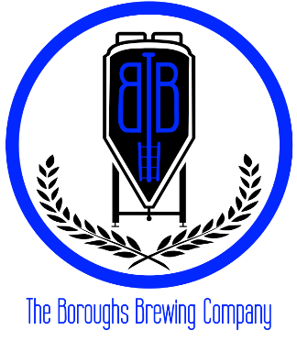
21A Furnace Street, Danielson, CT 06239
Name | 1/6 BBL
Cornucopia | 90
How Old Do Bears Go? | 80
Basic Chick | 80
Sexy Panties | 90

