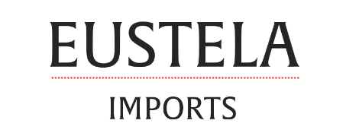
130 Old Gate Lane, Milford, CT 06460
Effective Pricing June 1, 2020

Item # | Item Description | Vintage | Bottle Size | Bottles per Case | Selling Price
RBL18 | Riesling Blue Light | 2018 | 750mL | 6/case | $ 84.92
RDM17 | Romane-Domaine Mesclances | 2017 | 750mL | 6/case | $ 50.00
RDM18 | Romane-Domaine Mesclances | 2018 | 750mL | 12/case | $ 104.00
CDM18 | Charmes-Domaine Mesclances | 2018 | 750mL | 12/case | $ 80.00
CST18 | Cuvée St. Mitre Rosé | 2018 | 750mL | 12/case | $ 99.92
SBS18 | Sylvain Bailly Sancerre | 2018 | 750mL | 12/case | $ 151.40
HGSB19 | Hans Greyl Savignon Blanc | 2018 | 750mL | 12/case | $ 78.00
PVM18 | Parlez Vous Malbec | 2018 | 750mL | 12/case | $ 84.00

