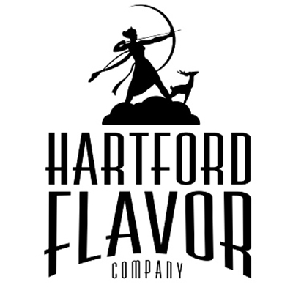
Hartford Flavor Company
30 Arbor St., Suite 107
Hartford, CT 06106
www.HartfordFlavor.com
Lelaneia@HartfordFlavor.com
860.604.9767
DSP-CT-21008
CT Lic # LML522

Wild Moon Liqueurs CT, FOB Price List
FLAVOR Size 375 Bottle Case of 12
Wild Moon Cucumber 375 ml $14.00 $168.00
Wild Moon Rose 375 ml $14.00 $168.00

Wild Moon Lavender 375 ml $14.00 $168.00
Wild Moon Birch 375 ml $14.00 $168.00
Wild Moon Chai Spice 375 ml $14.00 $168.00
Wild Moon Cranberry 375 ml $14.00 $168.00
Wild Moon Lime 375 ml $14.00 $168.00
Wild Moon Chocolate 375 ml $14.00 $168.00
FLAVOR Size 750 Bottle Case of 12
Wild Moon Cucumber 750 ml $21.50 $258.00
Wild Moon Rose 750 ml $21.50 $258.00
Wild Moon Lavender 750 ml $21.50 $258.00
Wild Moon Birch 750 ml $21.50 $258.00
Wild Moon Chai Spice 750 ml $21.50 $258.00
Wild Moon Cranberry 750 ml $21.50 $258.00
Wild Moon Lime 750 ml $21.50 $258.00
Wild Moon Chocolate 750 ml $21.50 $258.00

FLAVOR Size 100 Bottle_____Case of 24
Wild Moon Cucumber 100 ml $3.25 $78.00
Wild Moon Rose 100ml $3.25 $78.00
Wild Moon Lavender 100 ml $3.25 $78.00
Wild Moon Birch 100 ml $3.25 $78.00
Wild Moon Chai Spice 100 ml $3.25 $78.00
Wild Moon Cranberry 100 ml $3.25 $78.00
Wild Moon Lime 100 ml $3.25 $78.00
Wild Moon Chocolate 100 ml $3.25 $78.00

Variety Pack Size 6 pack Case of 4
6 pack, one of each flavor, 100 ml size ea. $21 case of 4 = $84
--------------------------------------------------------------------------------------------------------------------------------------------------
Wild Moon Botanics _______Size 375ml Bottle______Case of 12
Wild Moon Botanics 7 Lemon 375ml $15.50 $186.00
Wild Moon Botanics Roasted Dandelion Root 375ml $15.50 $186.00
Wild Moon Botanics Sage 375ml $15.50 $186.00
Wild Moon Botanics Sumac 375ml $15.50 $186.00

Wild Moon Botanics _______Size 750ml Case of 12
Wild Moon Botanics 7 Lemon 750ml $23.00 $276.00
Wild Moon Botanics Roasted Dandelion Root 750ml $23.00 $276.00
Wild Moon Botanics Sage 750ml $23.00 $276.00
Wild Moon Botanics Sumac 750ml $23.00 $276.00

Hartford Flavor Vodka _______Size 750ml Bottle Case of 6
Hartford Flavor Organic Vodka 750ml $15.50 $93.00
Hartford Flavor Vanilla Vodka 750ml $19.00 $114.00
Hartford Flavor Organic Espresso Vodka 750ml $19.00 $114.00
Hartford Flavor Orange Vodka 750ml $19.00 $114.00
Hartford Flavor Organic Raisin Fig Vodka 750ml $19.00 $114.00

Hartford Flavor Vodka nips Size 100ml Bottle_____Case of 24
Hartford Flavor Organic Vodka 100ml $3.00 $72.00
Hartford Flavor Vanilla Vodka 100ml $3.50 $84.00
Hartford Flavor Organic Espresso Vodka 100ml $3.50 $84.00
Hartford Flavor Orange Vodka 100ml $3.50 $84.00
Hartford Flavor Organic Raisin Fig Vodka 100ml $3.50 $84.00

