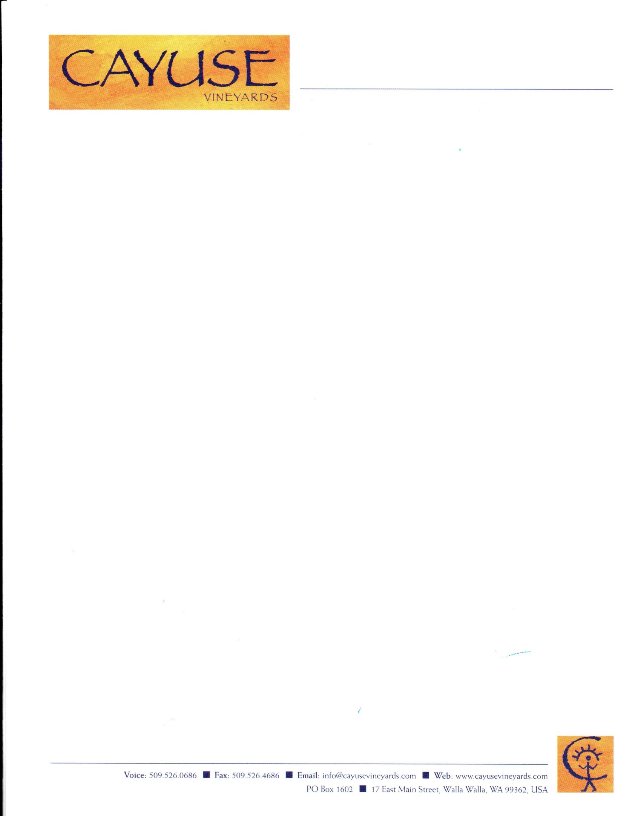

**2020 Pricelist**

|  |  |  |
| --- | --- | --- |
| **Wine** | **Brand registration #** | **Price per bottle** |
| En Chamberlin Vineyard Syrah | LBD.0062102 | $82.00 |
| En Cerise Vineyard Syrah | LBD.0062103 | $82.00 |
| Cailloux Vineyard Syrah | LBD.0062104 | $82.00 |
| Cailloux Vineyard Viognier | LBD.0128072 | $75.00 |
| Bionic Frog Syrah | LBD.0062105 | $110.00 |
| Camaspelo | LBD.0062106 | $82.00 |
| The Lovers | LBD.0104116 | $92.00 |
| God Only Knows Grenache | LBD.0104117 | $92.00 |
| Impulsivo Tempranillo | LBD.0104118 | $92.00 |
| Armada Vineyard Syrah | LBD.0104119 | $92.00 |
| Widowmaker Cabernet-Sauvignon | LBD.0104120 | $92.00 |
| Flying Pig | LBD.0104121 | $92.00 |
| Edith Grenache Rosé | LBD.0111924 | $40.00 |
| Wallah Wallah Special Syrah #11 | LBD.0128071 | $175.00 |
| Horsepower Vineyards The Tribe Vineyard Syrah | LBD.0111929 | $126.00 |
| Horsepower Vineyards Sur Echalas Grenache | LBD.0111928 | $126.00 |
| Horsepower Vineyards Sur Echalas Syrah | LBD.0128070 | $126.00 |
| Horsepower Vineyards High Contrast Vineyard Syrah | LBD.0148404 | $126.00 |
| No Girls Grenache | LBD.0111925 | $76.00 |
| No Girls Syrah | LBD.0111927 | $76.00 |
| No Girls Tempranillo | LBD.0128069 | $76.00 |
| Hors Categorie Syrah | LBD.0148403 | $250.00 |