Rosedale Vineyards LLC Wholesale List February 2020
Contact: Marshall Epstein 860-810-4440
Rosedale Vineyards LLC 25 East Weatogue Street, Simsbury, CT 0670
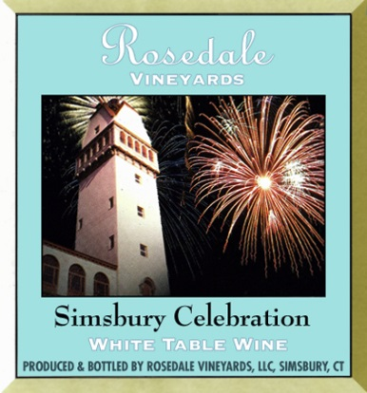
Simsbury Celebration
Our town shines in this 350th Anniversary commemorative bottling of Simsbury Celebration. Featuring our estate grown Seyval Blanc with Chardonnay harvested in California. Notes of cantaloupe, honey, green apple, faint pear and citrus play off a background of bright minerality courtesy of our unique soils of the Farmington River Valley. Lightly oaked with a creamy texture, this wine will pair deliciously with your favorite seafood dish. 68% Seyval Blanc (R), 32% Chardonnay 750 ml
Wholesale: $10.75/Bottle ($129.00/Case)
Suggested Retail: $18/Bottle ($216/Case)

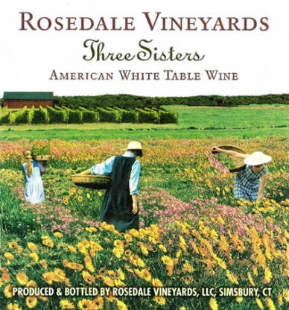
Three Sisters
Cayuga, one of the major varieties grown at Rosedale, is paired with Sauvignon Blanc resulting in a bright, citrus-noted wine with harmonious layers of grapefruit, pineapple and melon. An elegant long finish ensures this is surely a wine to remember. Pair with grilled white fish or fresh summer salads.
68% Cayuga (R), 32% Sauvignon Blanc 750ml

Wholesale: $10.75/Bottle ($129.00/Case)
Suggested Retail: $18/Bottle ($216/Case)

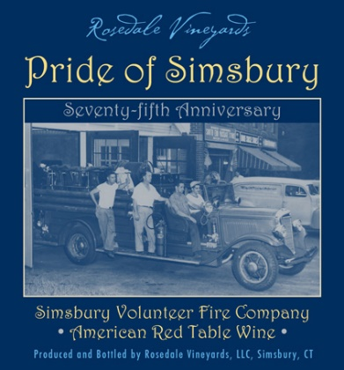
Pride of Simsbury
Layers of cherry, caramel, and dark berries blend with cedar, and sage over hints of nuanced oak . A wine to be savored fresh and fruity now or aged a year or two more to allow the tannins to soften. The choice is yours. 66% Cabernet Sauvignon, 20% Merlot, 14% Syrah 750 ml

Wholesale: $12.42/Bottle ($149.00/Case)
Suggested Retail: $25/Bottle ($300/Case)

