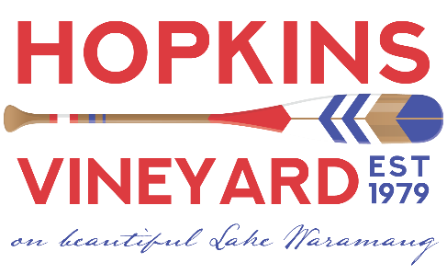
Hopkins Vineyard LLC
25 Hopkins Road
Warren CT 06777
www.hopkinsvineyard.com
contact@hopkinsvineyard.com
Contact: Hilary Criollo
CT Tax ID 8628901-000
Permit # LFW.0000043

Brand Price Posting to CT Liquor Control Commission
June 2021

Label Name | Bottle Size | Bottle Price | Case Price | Suggested Retail
Sachem’s Picnic | 750 ml | 12.62 | 150.00 | 19.00
Westwind | 750 ml | 12.62 | 150.00 | 19.00
Duet | 750 ml | 13.28 | 158.00 | 20.00
Red Barn Red | 750 ml | 13.28 | 158.00 | 20.00
Vineyard Reserve | 750 ml | 15.26 | 182.00 | 23.00
Apple Cider | 750 ml | 11.30 | 135.00 | 17.00
Peach Wine | 750 ml | 11.30 | 135.00 | 17.00
Lady Rosé | 750 ml | 16.58 | 198.00 | 25.00
Chardonnay | 750 ml | 17.24 | 206.00 | 26.00
Cabernet Franc | 750 ml | 18.56 | 222.00 | 28.00
Silver Label | 750 ml | 25.16 | 301.00 | 38.00
Ice Wine (12) | 375 ml | 29.78 | 356.00 | 45.00
Night Owl (24) | 375 ml | 11.30 | 270.00 | 17.00
Lemberger | 750 ml | NA | NA | 29.00
Riesling | 750 ml | NA | NA | 25.00
EH Brandy | 375 ml | NA | NA | 48.00

