39B Shelter Rock Road
Danbury, CT 06810

Phone: 203/801-5218
Fax: 203/972-9054
Email: psvallely@charteroakbrewing.com
Website: www.charteroakbrewing.com

Charter Oak Brewing Company, LLC
P. Scott Vallely
President

August 26, 2021
Consumer Protection Liquor Control
Hartford, CT 06103

RE: Revised Price posting for LMB 1567 Effective October 1, 2021

Style Price to Distributor
Charter Oak 1687 Brown Ale
-12oz 6 pack 24 cans $25.25
1/6 log (5.17 gallons) draft beer $48.00
½ keg (15.5 gallons) draft beer $117.00

Charter Oak Royal Charter Pale Ale
-12oz 6 pack 24 cans $25.25
1/6 log (5.17 gallons) draft beer $48.00
½ keg (15.5 gallons) draft beer $117.00

Charter Oak Wadsworth IPA
-12oz 6 pack 24 cans $27.00
1/6 log (5.17 gallons) draft beer $51.00
½ keg (15.5 gallons) draft beer $124.00

Charter Oak Stubborn Yankee Lager
-12oz 6 pack 24 cans $26.25
1/6 log (5.17 gallons) draft beer $51.00
½ keg (15.5 gallons) draft beer $124.00

Little Charter Session IPA
-12oz 6 pack 24 cans $26.25
1/6 log (5.17 gallons) draft beer $51.00
½ keg (15.5 gallons) draft beer $124.00

Charter Oak Legendary
-12oz 6 pack 24 cans $41.50
1/6 log (5.17 gallons) draft beer $58.00
½ keg (15.5 gallons) draft beer $137.00

Charter Oak Charter
-12oz 6 pack 24 cans $44.50
1/6 log (5.17 gallons) draft beer $63.00
½ keg (15.5 gallons) draft beer $147.00

Charter Oak Oak Beer
-12oz 6 pack 24 cans $49.00
1/6 log (5.17 gallons) draft beer $73.00
½ keg (15.5 gallons) draft beer $162.00

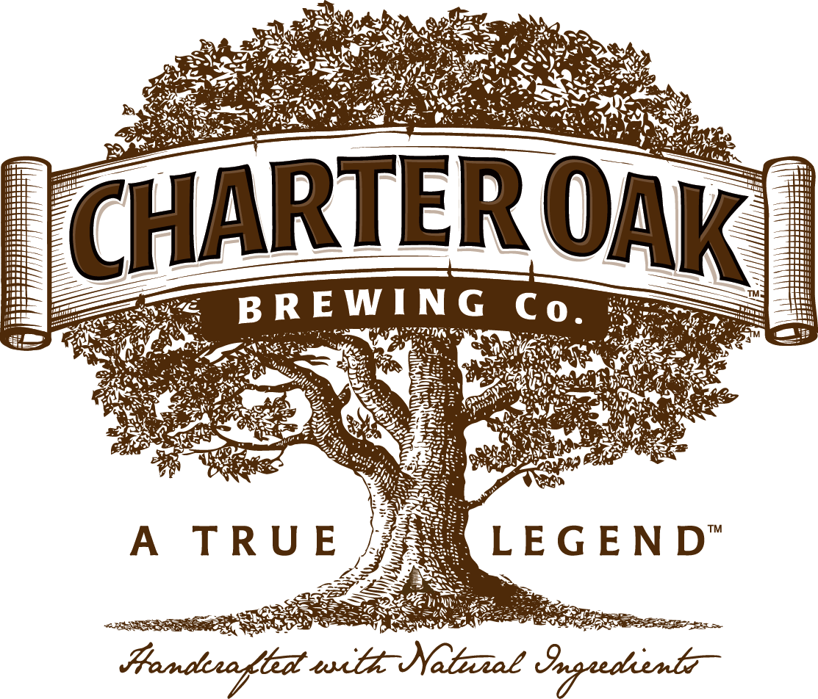

Charter Oak Brewing

