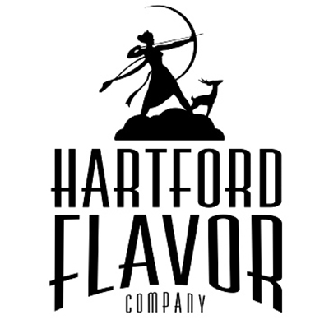
Hartford Flavor Company
30 Arbor St., Su 107-108
Hartford, CT 06106
www.HartfordFlavor.com
Lelaneia@HartfordFlavor.com
860.604.9767
DSP-CT-21008
CT Lic # LML522

Wild Moon Liqueurs FOB Price List May 2019
FLAVOR Size 375 Bottle Case 12
Wild Moon Cucumber 375 ml $11.00 $132.
Wild Moon Rose 375 ml $11.00 $132.

Wild Moon Lavender 375 ml $11.00 $132.
Wild Moon Birch 375 ml $11.00 $132.
Wild Moon Chai Spice 375 ml $11.00 $132.
Wild Moon Cranberry (Seasonal) 375 ml $11.00 $132.
Wild Moon Lime 375 ml $11.00 $132.
FLAVOR Size 750 Bottle Case 12
Wild Moon Cucumber 750 ml $18.00 $216.
Wild Moon Rose 750 ml $18.00 $216.
Wild Moon Lavender 750 ml $18.00 $216.
Wild Moon Birch 750 ml $18.00 $216.
Wild Moon Chai Spice 750 ml $18.00 $216.
Wild Moon Cranberry (Seasonal) 750 ml $18.00 $216.
Wild Moon Lime 750 ml $18.00 $216.

FLAVOR Size 100 Bottle_______Case 24
Wild Moon Cucumber 100 ml $2.55 $61.20
Wild Moon Rose 100ml $2.55 $61.20
Wild Moon Lavender 100 ml $2.55 $61.20
Wild Moon Birch 100 ml $2.55 $61.20
Wild Moon Chai Spice 100 ml $2.55 $61.20
Wild Moon Cranberry (Seasonal) 100 ml $2.55 $61.20
Wild Moon Lime 100 ml $2.55 $61.20
Variety Pack Size 6 pack Case 4
6 pack, one of each flavor, 100 ml size ea. $17.30 case of 4 = $69.20

